Exam 1

|  |  |  |  |  |
| --- | --- | --- | --- | --- |
| Instructor: | Brandon A. Moe |  | Name: |  |
| Results: | / 200 |  | Class: | LabVIEW Summer Class |
|  |  |  | Date: |  |

This exam will be out of 200 points. 100 points will come from multiple choice/matching/fill in the blank. 25 points will come form from True False. 75 points will come from writing / interpreting code.

1. Boolean is a
   1. Numbers
   2. Letters
   3. Words
   4. True/False
2. What is this
   1. For Loop
   2. While Loop
   3. Case Loop
3. 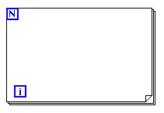What is this
   1. For Loop
   2. While Loop
   3. Case Loop
4. What is this
   1. Feedback Node
   2. Shared Variable
   3. Terminal
5. What is this
   1. Case Structure
   2. Event Structure
   3. Flat Sequence
6. Match the following color with their data type.

|  |  |  |
| --- | --- | --- |
| Orange |  | String/char |
| Green |  | Boolean |
| Blue |  | Double |
| Pink |  | Int |

1. Complete the logic table for an AND gate.

|  |  |  |
| --- | --- | --- |
| Input 1 | Input 2 | Output |
|  |  |  |
|  |  |  |
|  |  |  |
|  |  |  |

1. What does this LabVIEW Function do?
   1. Negate Integers
   2. Negate Doubles
   3. Negate Boolean
2. What company provides the Talon SRX and software?
   1. Cross The Road Electronics
   2. Andy Mark
   3. Arrow
   4. FIRST
3. What’s one function we do not do with the Talon SRX
   1. Auto assign motor voltage
   2. PID
   3. Read RPM
   4. Run on PWM
4. What is a potentiometer
   1. Reads RPM
   2. Reads Voltage
   3. Reads angle
5. What is the maximum size of an Integer?
   1. 255 bits
   2. 32 bits
   3. 264 bits
   4. 1 bits
6. What is the maximum bandwidth the FMS allows one robot?
   1. 6 Mb
   2. 7 Mb
   3. 8 Mb
7. Which of the following way is used to troubleshoot a robot? (Circle all that apply)
   1. Breakpoints
   2. Probes
   3. Ask the hardware guy to look at your program
   4. Tracing
   5. Trial and Error
8. What is the IP address to get into RoboRio Imaging? (works on any Rio)
   1. 172.22.11.2
   2. 172.10.30.26
   3. 10.30.26.5.
   4. 10.30.26.2.
9. What are setpoints used for?
   1. To set a point
   2. To pass data to a subsystem
   3. Tell the subsystem what operation to use
   4. Execute a program
10. What must every operation need?
    1. A setpoint
    2. A data value
    3. A command that calls it
    4. A Boolean value
11. What is the default operation?
    1. Read current
    2. Off
    3. Reserve
    4. Immediate
12. Where do you initialize objects in a subsystem? (Circle Number)

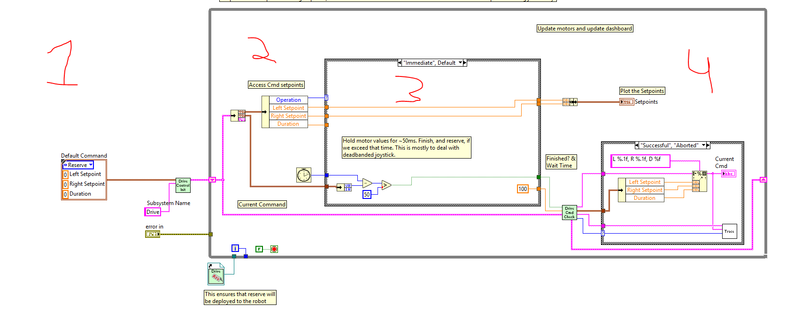

1. In Visual Studios, what are version numbers of code called?
   1. Version
   2. Change Set
   3. Iteration
2. In Visual Studios when you have code checked out, what is the term when you check code back in?
   1. Check in pending changes
   2. Upload Code
   3. Upload iteration
   4. Branch
3. What is the correct term(s) for a number in programming? (Circle all that apply)
   1. Integer
   2. String
   3. Char
   4. Short
   5. Long
   6. Double
4. Where do you program the functions of a subsystem?
   1. Operation
   2. Set point
   3. Command
   4. Controller
5. Name two 3026 custom VI.
   1. ___________________
   2. ___________________
6. What are the inputs to this VI? (circle them)
   1. 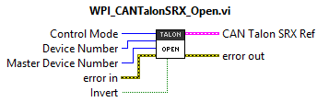
7. What does this symbol mean in LabVIEW? 
   1. _______________________________
8. How do you open the pallet in LabVIEW?
   1. ___________________________
9. What are the two possible displays on the front pallet? (they manipulate and show)
   1. ________________________
   2. ________________________
10. How many CPU does the RoboRio have?
    1. _________
11. What is the IP address of the RoboRio?
    1. 10.30.26._________
12. What does a breakpoint do?
13. How many characters can fit in a char?
14. What is a reentrant VI?
15. 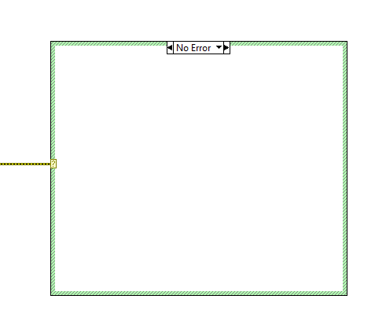Why would you make a VI reentrant?
16. When changing a reentrant VI, what must you do?
17. What is a terminal?
18. What is this?
19. What is the largest data type?
20. What is the unit of time used in LabVIEW?
21. Name the 6 functions of Robot Main?

If the answer is false, change the sentence to make the statement true.

41. T F A case structure can have a double input as its selector.

42. T F Functions of a subsystem are programed in the operation.

43. T F Commands are sent as a string.

44. T F Read current operation is ran on a terminating loop.

45. T F Integers can be any positive, negative, decimals, and zero number.

46. T F Data values are passed through operations.

47. T F Joysticks get initialized in its subsystem.

48. T F Talon SRX is found under the control pallet.

49. T F With both numbers being integers 7/3 = 2.333

50. T F The formula node lets the user select a formula from memory.

Extra Credit (1 points each)

The roboRio runs on the ___________________ operating system.

What is the ASCII value for the number 0? __________

What is the maximum number in a int? ________________________

Give a value, (other than true, false, 0, 1) , that would make a Boolean true and explain why.

What is the official name for PID?

_______________________ -- ____________________ -- ____________________ controller

Coding Question 1

You come across the problem of you need to make a calculator in LabVIEW. You are given the following partial code. It takes three arguments, operand 1, operand 2 and the operation. Complete the code to make this vi functioning. Your default should return 0.

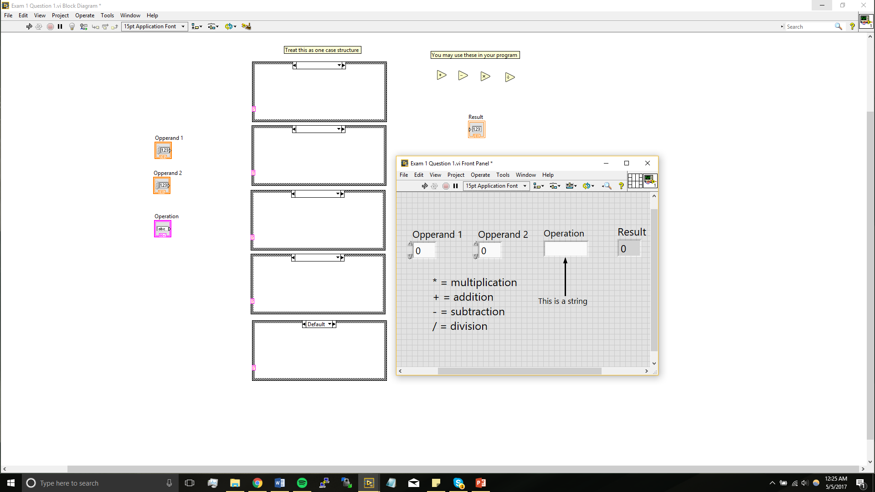

Coding Problem 2

Brandon is working on the shooter subsystem for the robot and gives up because it isn’t working. Find all the errors in his code and make the proper fixes. All the fixes have to do with command and control. (There are 11 fixes. If things need to be moved, they move in a group. EX: all the components for the shooter would move in a group and count as 1 fix. If you find all 11 you will get 2.5 bonus points. Finding 10 gets full credit.

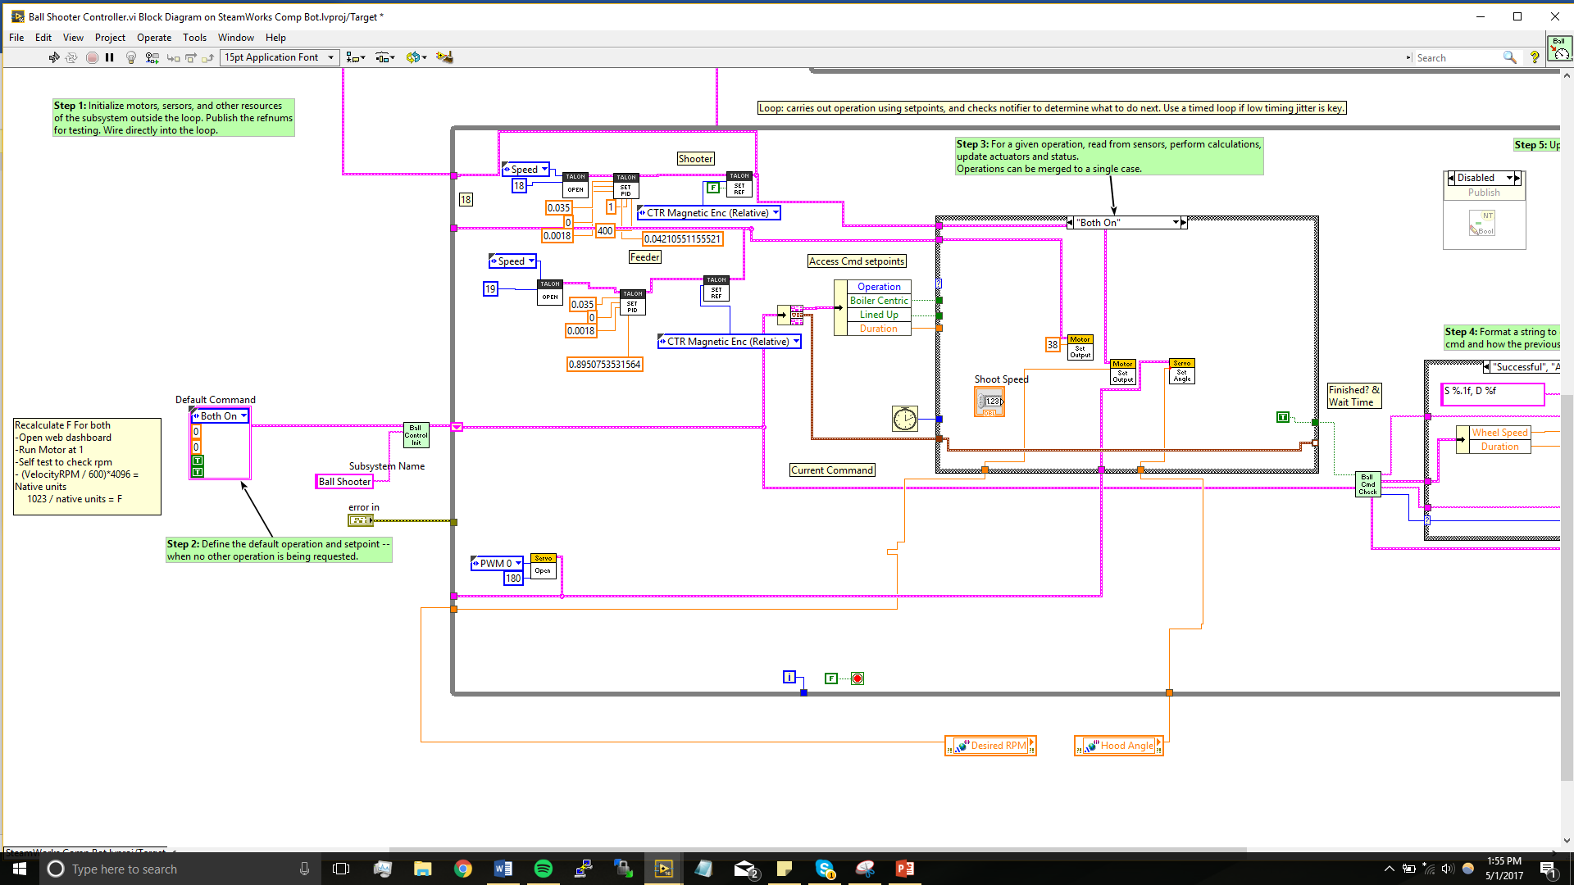

Coding Problem 3

Write an explanation to what this section of code does. Then solve for distance, hood angle, and desired rpm when COG Y Boiler is 302. Do the same calculation for when the COG_Y is 0.

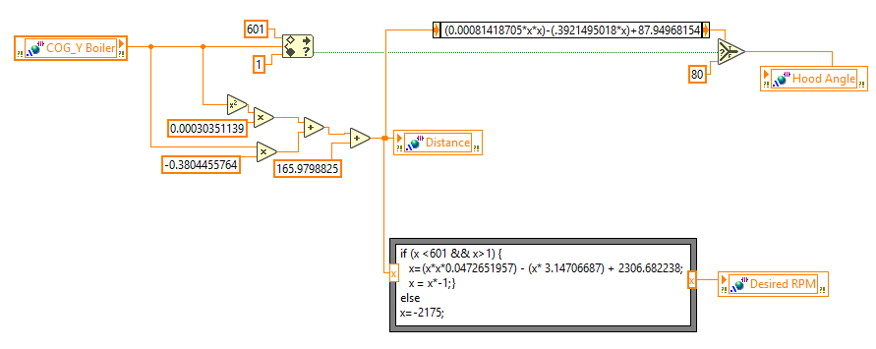

|  |  |  |
| --- | --- | --- |
|  | Calculation 1 | Calculation 2 |
| COG_Y Boiler | 302 | 0 |
| Distance |  |  |
| Desired RPM |  |  |
| Hood Angle |  |  |

Detailed Explanation on how this code works: